How Can We Control Quantum Spins?

Quantum Spin Choreography Using Resonance

Table of Contents

*Expected Learning Outcomes* 2

Background Information 3

Classwide Discussion 4

Introducing the Bloch Sphere Representation for Two-Level Quantum Systems 4

Bloch Sphere Representation 5

Guided Inquiry Questions 7

Quantum Spin Control 7

Initializing Spin States 7

Guided Inquiry Questions 7

Getting started with the Bloch Simulator 7

Controlling transitions between spin states 9

Guided Inquiry Questions 10

Nutation and Pulses 12

Guided Inquiry Questions 14

Reflection Questions 14

Supplemental Reading 14

Cited Sources 14

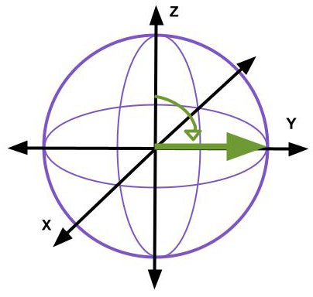

***Example Real-World Application*** Qubits - or quantum bits - are the quantum version of the classical binary bits used in traditional computing. A qubit is a two-state (or two-level) quantum system and quantum mechanics allows the qubit to be in a superposition of both states simultaneously which enables quantum computing advantages compared with traditional computing. The two spin states of a spin-1/2 particle can be treated as a qubit and qubit states are usually respresented in the Bloch sphere representation (1).

## *Expected Learning Outcomes*

*At the end of this module, students should be able to…*

1. *Identify two primary ways scientists can control quantum spins*
2. *Explain the importance of resonance in controlling quantum spins*
3. *Construct new Bloch sphere representation from previous representations (modified* [*Scientific Ability A2*](https://sites.google.com/site/scientificabilities/rubrics)*)*

**“The important thing in science is not so much to obtain new facts as to discover new ways of thinking about them.”**

— Sir Williams Bragg

# Background Information

Let’s review some of the aspects of quantum spin we have explored thus far which each offer different perspectives that we will combine into a fuller picture that hints at ways of controlling quantum spins.

ScientistHP, [CC BY-SA 4.0](https://creativecommons.org/licenses/by-sa/4.0) via Wikimedia Commons. You can find more information on the [file information page](https://commons.wikimedia.org/wiki/File:Zeeman_splitting.jpg).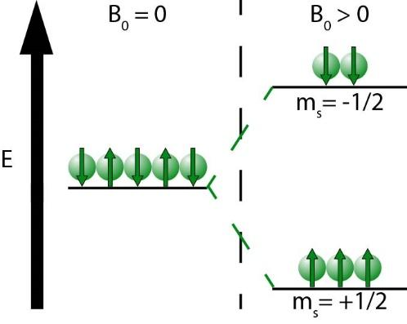

***Comment on the figure.*** This representation of individual spin-1/2 particles with up and down arrows is helpful in many ways, but can be deceptive. *In fact, the spin angular momentum (and its associated spin magnetic moment) of a single spin can point in all possible directions, even in the presence of an external magnetic field.*

**Quantum spin energy levels split in the presence of a magnetic field.** We have seen with the [Zeeman effect](https://en.wikipedia.org/wiki/Zeeman_effect) that when quantum spins are placed in a magnetic field, the different quantum spin states will have distinct energy levels. Focusing on spin-½ particles, there will be two distinct energy levels. The lower energy level is the spin-up state, $m_{s}=+1/2$ and the upper energy level is the spin-down state, $m_{s}=-1/2$.

**spin flip** -transition from one spin-½ quantum state to another (e.g. ↑ to ↓)

**The difference in energy between the two energy levels is directly proportional to the strength of the external magnetic field.** Comparing this with our understanding of energy-level transitions, the larger the external magnetic field, the higher the frequency of electromagnetic radiation wilI need to be used to cause transitions between the different spin states. In the spin-½ example, this transition is often call a **spin flip**. If there is no magnetic field present, $B_{0}=0$, then there is no way to differentiate between the quantum spin states and thus we cannot say anything conclusively about the actual spin state. *In quantum mechanics, no information about a quantum system is known until it is measured, and the quantum system can be in any of the allowed possible states until measured.*

**Quantum spins precess in the presence of a magnetic field.** We have seen with our physical model of quantum spin that quantum spins that have spin angular momentum not perfectly aligned or anti-aligned with the external magnetic field will now undergo precession. This precession is dictated by only a few parameters, the gyromagnetic ratio of the quantum spin and the strength of the external magnetic field.

$f_{0}= γ B_{0}$**Larmor precession frequency**

**The precession frequency of a given quantum spin is directly proportional to the strength of the external magnetic field.** The precession of a quantum spin about the external magnetic field is called Larmor precession, and the Larmor precession frequency is given by the gyromagnetic ratio $γ$ of the quantum spin and the strength of the external magnetic field, $B_{0}$. Each type of quantum spin has a unique gyromagnetic ratio, so that if you have a sample made of multiple different types of quantum spins placed in the same external magnetic field, you would measure different Larmor frequencies that would help you identify the different quantum spins present in the sample. If there is no magnetic field present, $B_{0}=0$, then there is no way to differentiate between the different quantum spins present in the sample.

## Classwide Discussion

* Based on the above information, what are two primary ways scientists can potentially ‘control’ quantum spins (i.e. put them into a particular spin-state)?
* What do you think the natural frequency would be for quantum spins in the presence of a magnetic field?

**resonance** - phenomenon when energy is injected into a physical system at a frequency matching the natural frequency of the system; this leads to the most efficient transfer of energy into the system and will result in the most amplified response of the system

* If we only send electromagnetic radiation at this ideal frequency (the natural frequency of our spin system), we will observe a phenomenon called **resonance**. Where else have you encountered resonance in your everyday life?

# Introducing the Bloch Sphere Representation for Two-Level Quantum Systems

We have seen two distinct representations of spin-½ quantum systems, and they may both appear at the moment to be entirely unrelated to each other. The goal of this section is to introduce a final, more accurate representation of a spin-½ quantum system that encapsulates all aspects of quantum spin we have explored thus far.

## Energy-Level Representation

In the energy-level representation, the lower-energy state is when the spin is aligned with the magnetic field because magnets tend to “like” aligning with other magnetic fields - e.g. a compass. Conventionally, the external magnetic field is pointing vertically up (along the +z direction), so the lower-energy state is the spin-up state and is typically denoted by the Greek letter $α$. The higher-energy state is then the spin-down state and is typically denoted by the Greek letter $β$. If you measure the spin-state along the direction of the magnetic field (the +z direction) then these are the two possible quantum spin states you will see.

However, when you are *not* actively measuring the quantum spin, it can be in either of those two states *or in any possible combination of those two states*. This is an example of **quantum superposition**, and is a property of quantum states that makes the quantum realm so different from our everyday world. There is no good way to visualize a superposition state using the energy-level representation, so we’ll need a different way to visualize all the possible quantum states for a two-level system - like our spin-½ particle placed in an external magnetic field.

**quantum superposition**- the principle of quantum superposition states that if a quantum system can be in one of many possible configurations, the most general quantum state is a combination of all these possibilities

## Bloch Sphere Representation

In the Bloch sphere representation, the quantum state of a two-level system is represented by an arrow that starts at the origin of a sphere and points to a particular point on the sphere. An arrow pointing straight up is usually the lower-energy state of the two-level system ( $α$ in our case), and an arrow pointing straight down is the higher-energy state ( $β$ in our case). However, you can also have a state that is represented by an arrow pointing in any other direction, and this would be a superposition state, which has no equivalent representation in the energy-level visualization.

How “close” the arrow is to being aligned with the $α$ state arrow or the $β$ state arrow tells you something about how likely you are to measure the spin-up state versus the spin-down state. So, quantum states in the upper hemisphere are more likely to be measured in the spin-up ($α$) state and quantum states in the lower hemisphere are more likely to be measured in the spin-down ($β$) state.

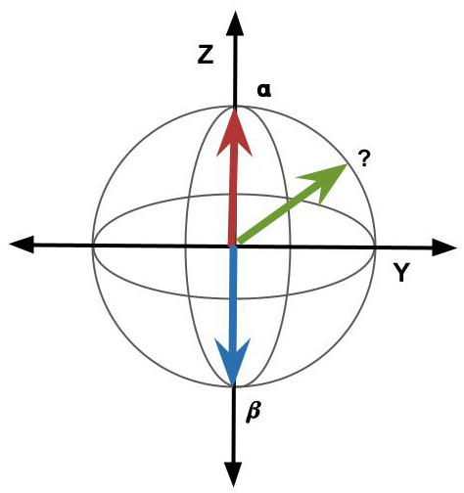

**Note:** If the fact that we are saying the spin is initially in a superposition state and then somehow hops into one of the two allowed states as soon as it is measured is troublesome to you, welcome to the club! This is the [measurement problem](https://en.wikipedia.org/wiki/Measurement_problem) in quantum mechanics that continues to plague physicists to this day!

## Guided Inquiry Questions

1. If the quantum spin is in the green state shown in the figure and then is measured along the z-direction (meaning it can be found in either $α$ or $β$), which state will it more likely be found in?
2. If the quantum spin is in a quantum state represented by an arrow aligned with the +y axis and then is measured along the z-direction (meaning it can be found in either $α$ or $β$), what is the percent probability of it being found in $α$? Being found in $β$? *Hint: Since there are only two allowed states, the percent probability of being found in $α$* ***plus*** *the percent probability of being found in $β$ must equal 100%.*

# Quantum Spin Control

In order to control quantum spins, scientists would like to be able to (1) reliably set up a quantum spin system into a known quantum state - called initialization - and (2) direct its transition into any other desired quantum state, including superposition states.

## Initializing Spin States

Physical systems ultimately all tend towards their lowest energy state. For example, even a spinning gyroscope will eventually slow down, topple over, and come to a rest. This transition to the lowest energy state is possible thanks to interactions with the environment. (This allows for energy to be exchanged with the environment in order for overall energy conservation.) Presumably, if you wait enough time and don’t purposely inject energy into the system, every physical system will eventually arrive at its lowest energy state.

## Guided Inquiry Questions

1. A common initialization state for quantum experiments would be the lowest energy level of the system. Give an argument for why you think that is a common choice.
2. For our spin-½ particles in the presence of an external magnetic field, what spin state would be the lowest energy level?
3. If we wanted to initialize our spins into the lowest energy state, what do you suggest we do?

## Getting started with the Bloch Simulator

The quantum state of a quantum system (when left to its own devices and not being measured) can smoothly transition from one state to another over time. This means the tip of the arrow would trace out a continuous path along the Bloch sphere. The dynamics of the quantum state of a spin-½ particle in the presence of magnetic fields is given by the [Bloch equations](https://en.wikipedia.org/wiki/Bloch_equations). Solving these equations is beyond the scope of this course, but we can visualize the resulting dynamics of the quantum state moving around on the Bloch sphere using the [Bloch Simulator](https://www.drcmr.dk/BlochSimulator/). Fortunately, these dynamics will almost directly correlate with the motion we observed of our physical model of quantum spin we explored in the previous module.

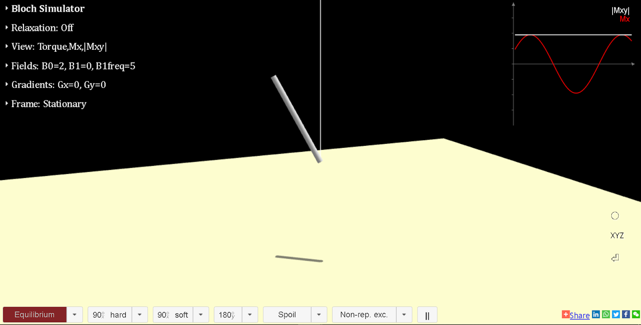

1. Open the [Bloch Simulator](https://www.drcmr.dk/BlochSimulator/) (<https://www.drcmr.dk/BlochSimulator/>) and describe what you see. What motion do you think is being depicted? What is being shown in the plot in the upper right-hand corner?
2. Is there a magnetic field being applied? If so, what direction is this magnetic field being applied?
3. In the upper-left corner, there are several drop-down menus for changing different parameters of the simulation. Click on the drop-down arrow for ‘Fields’. B0 is typically reserved for the large external magnetic field being applied in the +z direction. Observe what happens when you increase or decrease B0. Does this match with what we saw happen with our physical model of quantum spin?

**Need some help?** Check out our YouTube [tutorial video](https://www.youtube.com/watch?v=YnxmBojj6d4&list=PLiR1z2ZjMRdxCiAeI5M08eV7J2kSeojAG&index=2) for changing the magnetic field in the Bloch simulator.  
[https://www.youtube.com/watch?v=YnxmBojj6d4](https://www.youtube.com/watch?v=YnxmBojj6d4%20)

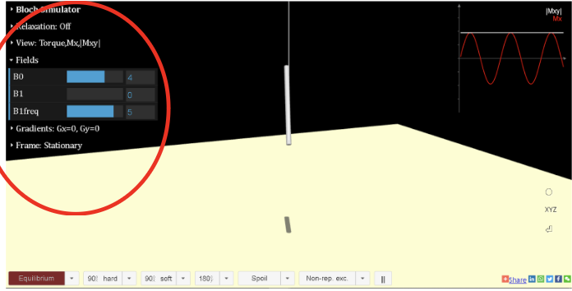

1. Click on the drop-down arrow for ‘Frame’ and change from ‘Stationary’ to ‘B0’. Describe what you observe now. What is happening when you switch from ‘Stationary’ to ‘B0’? In magnetic resonance (MR), scientists often reference the ‘lab frame’ and the ‘rotating frame’. Which of the possible frames in the simulator do you think would correspond to the lab frame? Which do you think would correspond to the rotating frame?

**Need some help?** Check out our YouTube [tutorial video](https://www.youtube.com/watch?v=ccIBypA0FVk&list=PLiR1z2ZjMRdxCiAeI5M08eV7J2kSeojAG&index=3) for changing the frame in the the Bloch simulator.  
<https://www.youtube.com/watch?v=ccIBypA0FVk>

1. Try clicking on the red ‘Equilibrium’ button in the lower left-hand corner. Describe what happens. What quantum state is the spin put in? *Note: This is a good way to initialize the simulator so that the system starts in a known quantum state!*

**Need some help?** Check out our YouTube [tutorial video](https://www.youtube.com/watch?v=N9Lbfk4eJNQ&list=PLiR1z2ZjMRdxCiAeI5M08eV7J2kSeojAG&index=1) to see what happens when you click the 'Equilibrium' button.  
<https://www.youtube.com/watch?v=N9Lbfk4eJNQ>

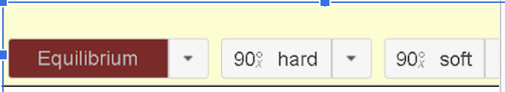

## Controlling transitions between spin states

One important aspect of quantum spin control is being able to control transitions between the available spin states (e.g. inducing a spin-flip). In the Bloch sphere representation, this would be smoothly moving the quantum state from a pure spin-up state to a pure spin-down state by following a continuous path along the Bloch sphere (passing through different superposition states along the way).

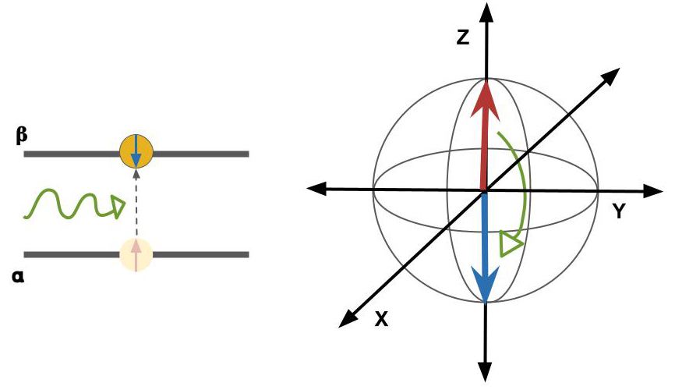

## Guided Inquiry Questions

1. Consider how the dynamics of the Bloch Simulator are very similar to the dynamics of the physical model of quantum spin we saw in the previous module. If we were to introduce another magnetic field to cause a spin-flip, what direction of the magnetic field should we be using (e.g. should the additional magnetic field be oriented in the X, Y, or Z direction?) Would you want the additional magnetic field to remain ‘on’ indefinitely, or would you need to turn it ‘off’ at some point? Explain your reasoning.

*Hint: Consider the spin-flip as a rotation about the x- or y-axis that only goes half-way around and then stops.*

1. In the Bloch Simulator, initialize the quantum state (using the ‘Equilibrium’ button) and turn off all the ‘Fields’ to 0 (B0, B1, and B1Freq). Under the menu ‘View’, you can **check** the checkbox next to ‘B1’ to show the B1 direction and **uncheck** the checkbox next to ‘Torque/B1eff’. Now increase the B1 field and observe what happens to the quantum state in the lab frame. Describe what happens. What direction is the B1 field pointing in? Will this potentially be helpful for causing a spin-flip?
2. For actual MR experiments, we cannot simply turn off the large external field B0, so we make B0 nonzero as well (but keep B1Freq set at 0) and observe what happens to the quantum state in the lab frame. Can you explain why that might be happening?

*Feel free to ask an instructor if you are unsure!*

1. Now, keep B0 and B1 at some non-zero value and observe what happens when you increase B1Freq. Explain what you think B1Freq is controlling.
2. Your goal is to try to replicate a spin-flip (starting from the spin-up/equilibrium state) with a non-zero B0 using B1. You can play with any of the settings in the ‘Fields’ menu. Record the values that you use in order to replicate a spin-flip. **When you think you have a possible solution, show it to your instructor!**
3. In order to induce a spin-flip using B1, what does B1Freq need to be? The units in the simulator are dimensionless, simply numbers showing the relative strength of the different variables. In actual MR experiments, what do you think the frequency of B1 would be (if you know the strength of the B0 field and the gyromagnetic ratio of the spin)?

*Hint: MR experiments are making use of* ***resonance,*** *and the natural frequency of spins in an external magnetic field is the Larmor frequency.*

1. In order to induce a spin-flip using B1, is the field B1 ‘on’ for a limited time? Usually, the sources of these B1 fields in MR are called pulses, and the different lengths of pulses are labelled by the angle of rotation they will cause the quantum state to undergo and the axis about which they will rotate the quantum state. For example, ${90}_{y}^{∘}$ would provide a short-lived B1 field in the y-direction that causes a ${90}^{∘}$ rotation about the y-axis. In the bottom row, to the right of the ‘Equilibrium’ button, you will see some options for ‘hard’ and ‘soft’ pulses. Try some of them out and observe what happens to the B1 field during the pulse and the resulting motion of the spin. What is the difference between ‘hard’ and ‘soft’ pulses?
2. Scientists typically like to view the spin dynamics in the rotating frame. View some of the pulses in the rotating frame. Why might looking at the spin dynamics in this frame be more convenient?

# Nutation and Pulses

The B1 field in the lab frame actually a rotating field in the x-y plane, and the frequency of rotation is ideally matched to the Larmor precession frequency due to the B0 field, $f_{0}=γB_{0}$- equivalent to ‘B1Freq’ being set equal to ‘B0’ in the simulator. This is a resonance condition, where the energy supplied by the B1 field matches exactly the natural frequency of the system (the Larmor precession frequency).

**Isidor Isaac Rabi** - a Physics Nobel Prize winner in 1944 for developing the atomic and molecular beam magnetic resonance method. When he sent a continuous source of light at a two-level quantum system at the resonance frequency, Rabi observed cyclical transitions between the two states, later called Rabi oscillations. When the frequency of light used is the Larmor frequency of a two-level spin-½ system, the frequency of these Rabi oscillations matches precisely with the nutation frequency.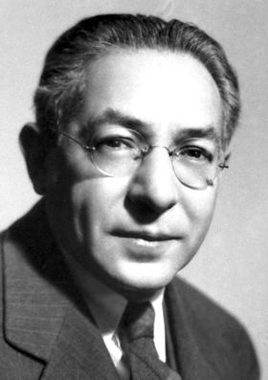

“My mother made me a scientist without ever intending to. Every other Jewish mother in Brooklyn would ask her child after school: So? Did you learn anything today? But not my mother. 'Izzy,' she would say, 'did you ask a good question today?' That difference — asking good questions — made me become a scientist.”  
Photographer Unknown, Public Domain (2) - Isidor Isaac Rabi

The use of a rotating magnetic field in the x-y plane at the Larmor precession frequency to induce spin flips turns out to be *exactly equivalent to sending electromagnetic radiation at the Larmor precession frequency*.

If this B1 field is left ‘on’, then in the Bloch representation, the quantum state oscillates back and forth between the spin-up and spin-down states in a periodic way at a frequency known as the **nutation frequency**,

$f_{1}= γ B_{1}$

These oscillations between spin-up and spin-down states are equivalent to Rabi oscillations, the response of a quantum two-level system when driven by a resonant electromagnetic field.

The B1 field can also be pulsed - only turned on for a short duration of time until the quantum spin is placed in the desired state. One can use the nutation frequency to determine how long a pulse should be to provide the desired amount of rotation. The smaller the B1 field (i.e. the weaker pulse), the lower the nutation frequency, and the longer the pulse that is needed for a given rotation angle.

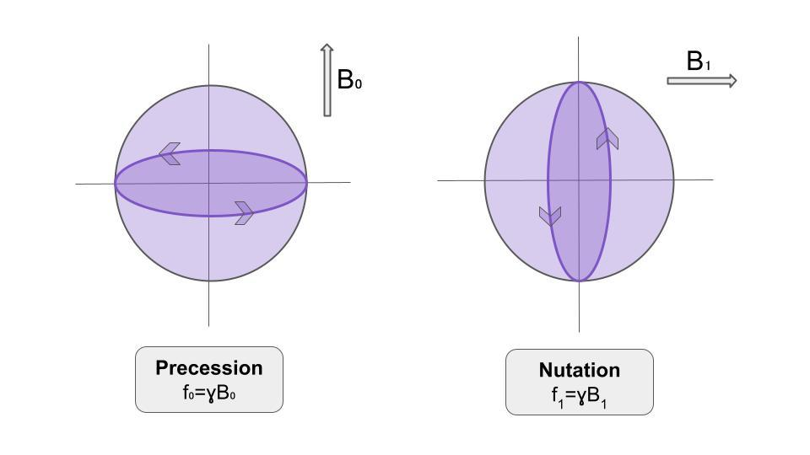

## Guided Inquiry Questions

1. Scientists typically consider a very short pulse duration as a ‘hard’ pulse. What parameter would you adjust in order to generate a ‘hard’ pulse? Give an explanation for your answer using the nutation frequency, $f_{1}=γB_{1}$.
2. With the addition of pulses, do we have the ability to effectively ‘control’ the quantum state? Why or why not?

# Reflection Questions

1. Why might scientists prefer the Bloch sphere representation for two-level quantum systems instead of the energy-level representation?
2. How is utilizing resonance an important aspect of quantum spin control?
3. View [this video](https://www.youtube.com/watch?v=zNFDAEOLGqg) (<https://www.youtube.com/watch?v=zNFDAEOLGqg>) using the magnetic torque apparatus from our previous module. Explain what you think is going on.
4. Write down the pulse sequence that led to [this video](https://www.youtube.com/watch?v=E-ZMaCq9Q3A) (<https://www.youtube.com/watch?v=E-ZMaCq9Q3A>). *Note: this video was taken in the rotating frame, so you want to use that frame when trying to replicate this pulse sequence using the simulator!*

# Supplemental Sources

* More Information about Bloch Sphere Simulator by creator Lars Hanson: <https://www.youtube.com/watch?v=sl_DbvmpsAc>
* Simple Simulator of a Compass and Spin in a Magnetic Field: <https://www.drcmr.dk/CompassMR/>

## Cited Sources

1. <https://en.wikipedia.org/wiki/Qubit> “Qubit Wikipedia article”
2. <http://nobelprize.org/nobel_prizes/physics/laureates/1944/rabi-bio.html> “Nobel Prize Bio for I. I. Rabi”